**Homework#16 Vincent Wong**

**UC Berkeley Data Bootcamp**

**July 2018**

**Aggregate the data found in the Citi Bike Trip History Logs to build a report**

How many trips have been recorded total during the chosen period?

* **Analyzed for the 1st Quarter of 2018**
* **2,538,066 trips over the past 24-hrs**

By what percentage has total ridership grown? **< 1% from Jan 2017 to Dec 2017**

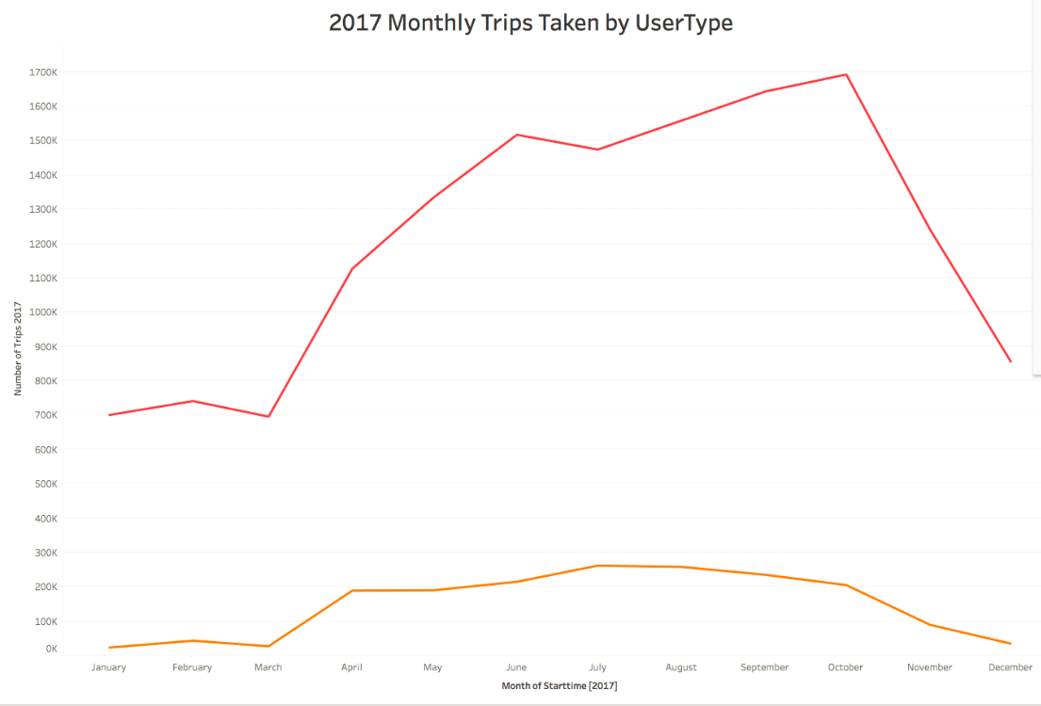

How has the proportion of short-term customers and annual subscribers changed? **No**

**There is a seasonal trend where the summer months both Customer and Subscriber ridership increases but both level off at the beginning and end of the year (2017 data).**

What are the peak hours in which bikes are used during summer months?

**4pm -8pm are the peak hrs during summer (2017 data)**

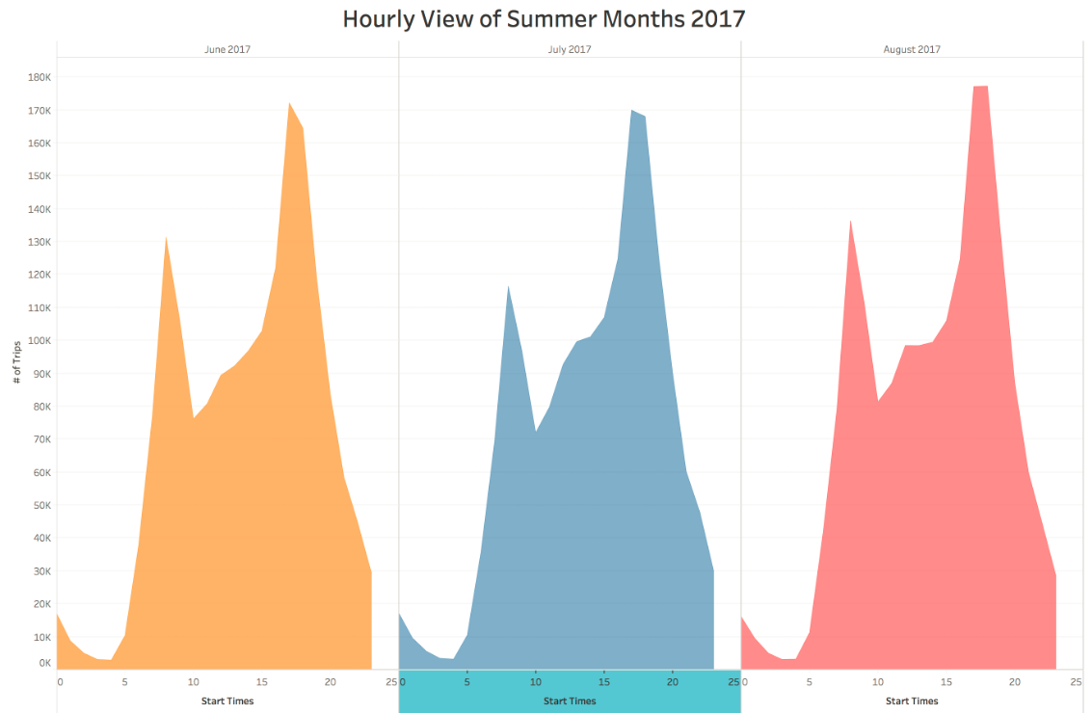

What are the peak hours in which bikes are used during winter months?

**There are two peaks in winter – 9am and 8pm (2017 data)**

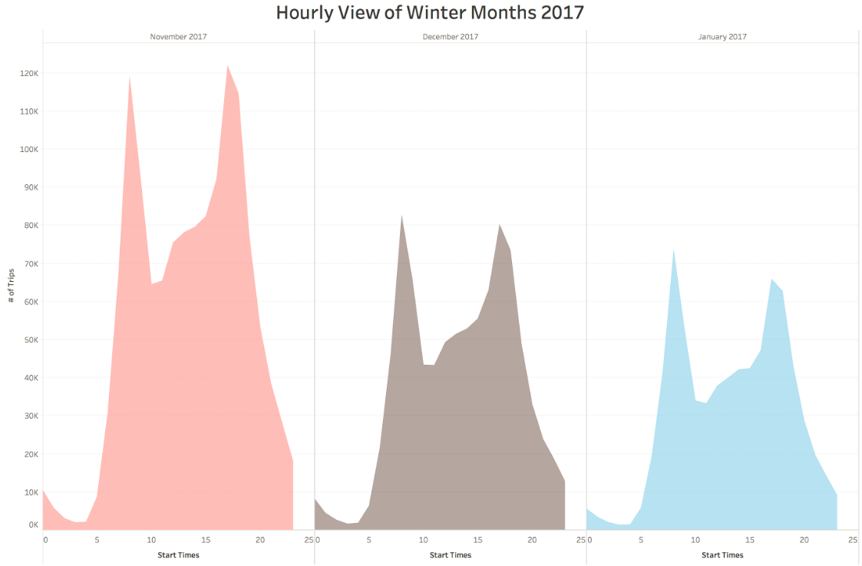

Today, what are the top 10 stations in the city for starting a journey? (Based on data, why do you hypothesize these are the top locations?) **See below table – The locations look to be near parks, so it is for recreational purposes.**

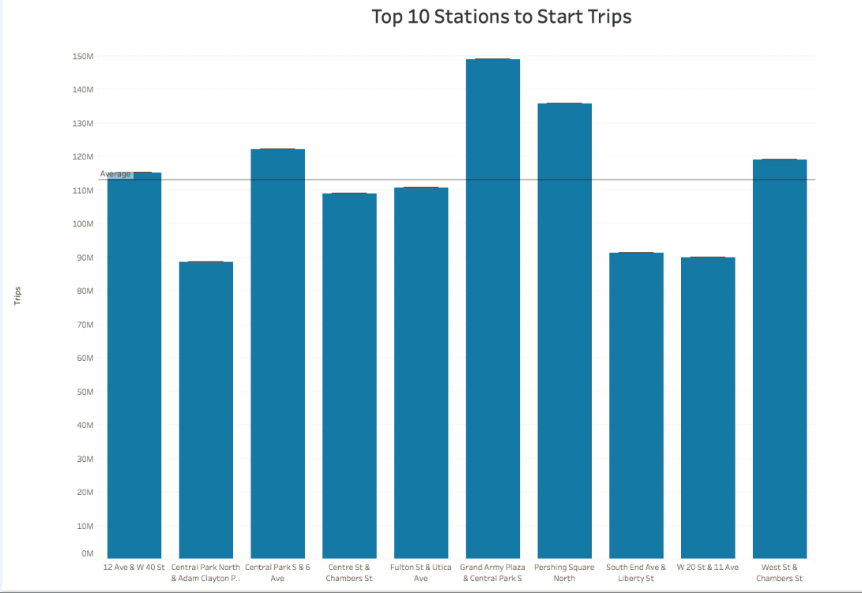

Today, what are the top 10 stations in the city for ending a journey? (Based on data, why?) **See below table. The ending journey looks to be transit centers, so people that are commuting.**

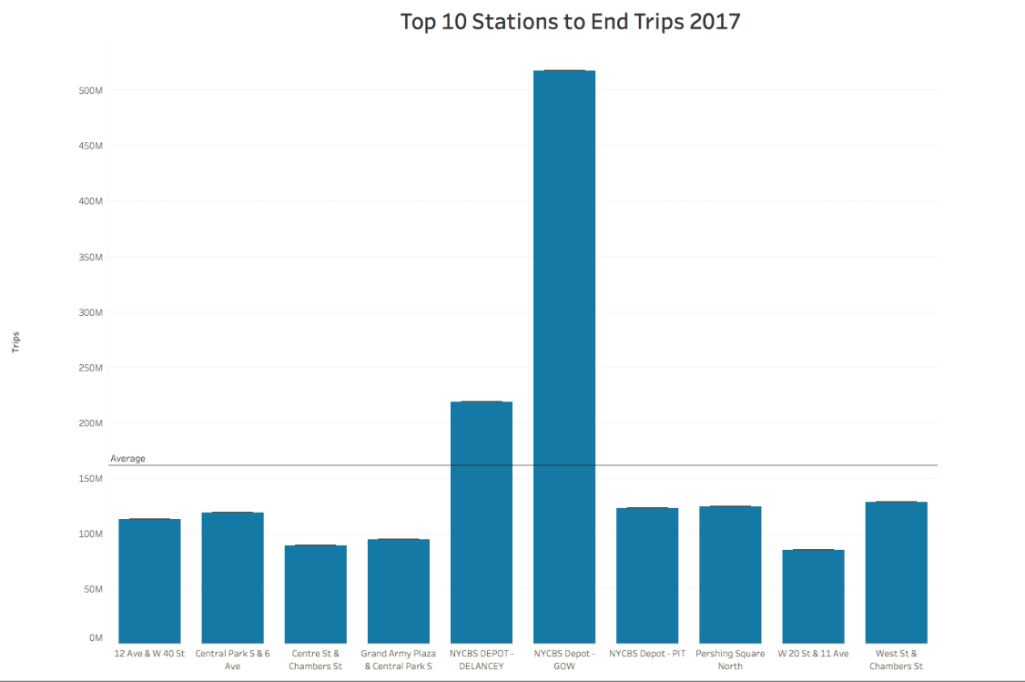

Today, what are the bottom 10 stations in the city for starting a journey? (Based on data, why?)

**It is the reverse for the Top 10, these are transit centers. So most people do not bike to work most likely since it may be slow. Most people need to get to work on-time and in a hurry.**

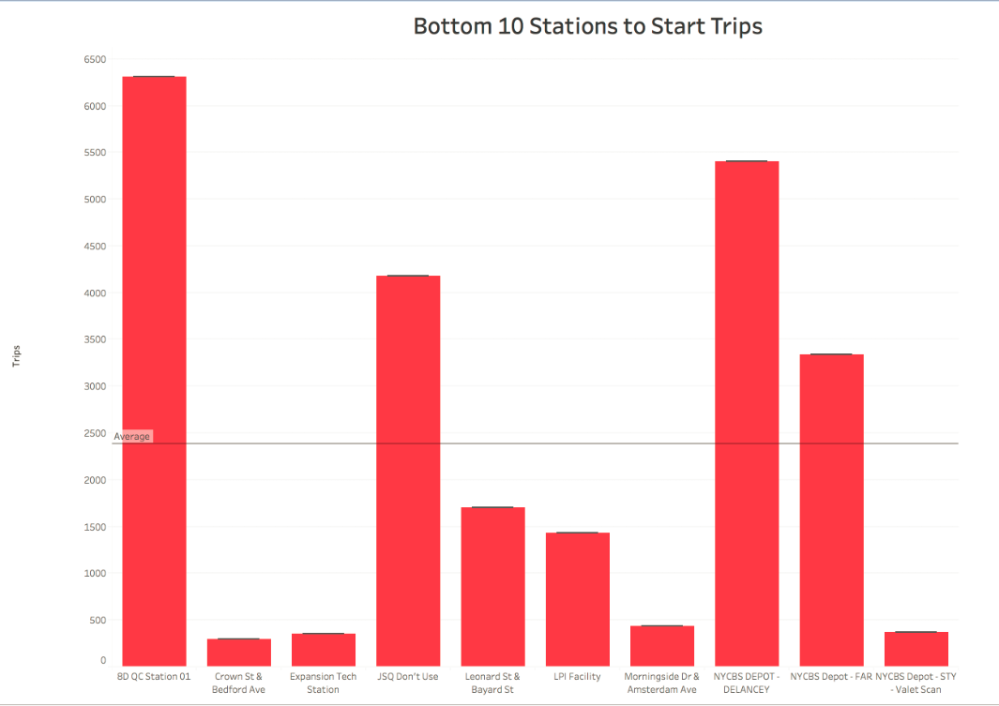

Today, what are the bottom 10 stations in the city for ending a journey (Based on data, why?)

**It is the reverse for the Top 10, these are parks. Most people are not going to end at the park, it doesn’t make sense.**

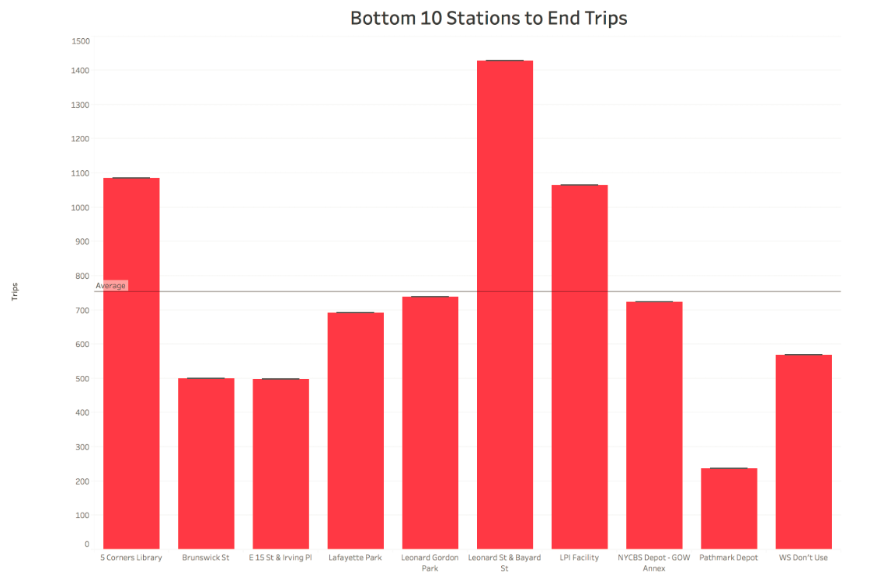

Today, what is the gender breakdown of active participants (Male v. Female)?

**The breakdown is almost 2 to 1 – Males to Females.**

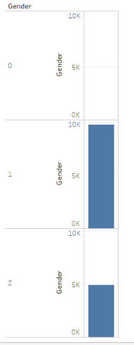

How does the average trip duration change by age? **The riders born in 1985 – 32yrs peak at trip duration. As riders get older and younger in both directions from 32yrs old decreases dramatically.**

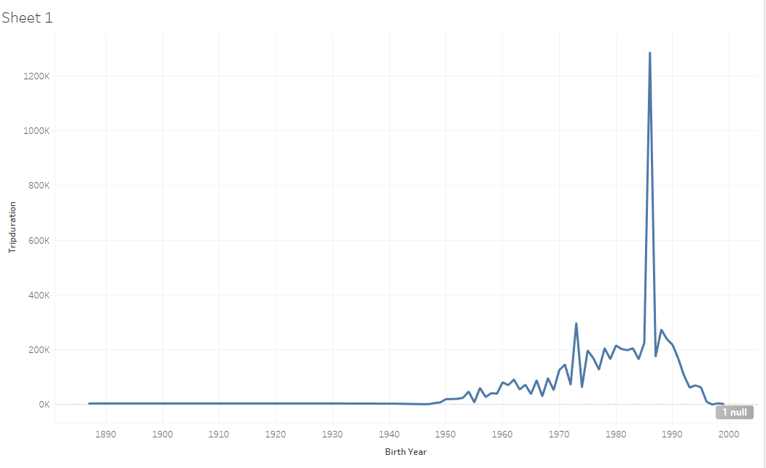

What is the average distance in miles that a bike is ridden? **The average miles rode per month ranges from 2.5 miles to 4.0 miles, with summer months being the highest.**

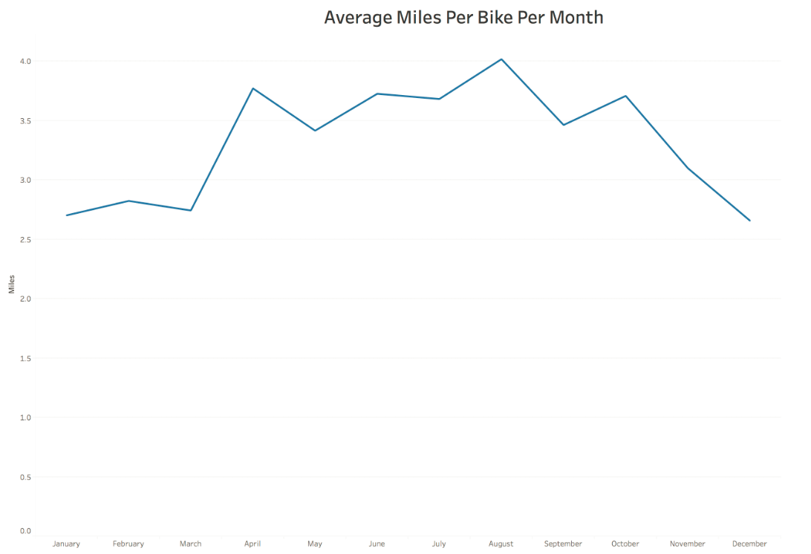

Which bikes (by ID) are most likely due for repair or inspection in the timespan?

**18K, 23K Bike IDs**

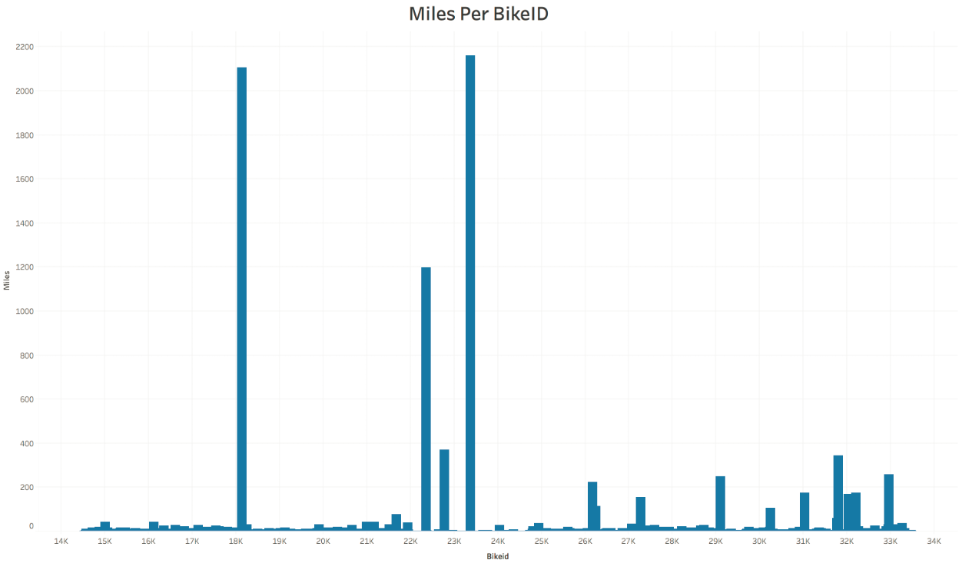

How variable is the utilization by bike ID? **The utilization by bike ID is very variable, with large number of riders less than 50 miles, and then some that peak over 2000 miles. This would be contrasting recreational vs. courier / commuter.**